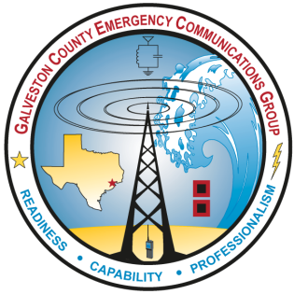Galveston County Emergency Communication Group
Membership Application Form
Name:
Call Sign:
Mailing Address:
City, State, Zip code:
Email address(es)

Home phone number:
Work phone number:
Cell phone number:
License Class:

Check bands and modes that you can operate:
MODE | HF | 6 METERS | 2 METERS | 222 MHz | 440 MHz | OTHER
SSB
CW
FM
DATA
PACKET
Other Modes
(specify below)
Mobile
Operation

Can you home station be operated without commercial power? Yes ( ) No ( )

Signature ______________________________________ Date________________
Return completed form to Director of GCECG at: cgtallman@earthlink.net

